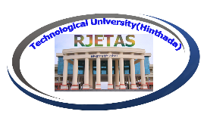
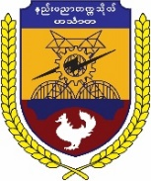
RESEARCH JOURNAL ON ENGINEERING, TECHNOLOGY AND APPLIED SCIENCE
RJETAS Volume-5, 2023

CALL FOR PAPERS

Technological University (Hinthada) publishes the Research Journal on Engineering, Technology and Applied Science (RJETAS) which is an interdisciplinary journal to enhance research work and to get a great improvement on innovation and research areas.
For the fifth publication of RJETAS, the authors are invited to submit full papers which are not published anywhere. The number of pages must not exceed 6 pages. All research work must be original and contains a list of key references. Papers will be accepted if the plagiarism is less than 30%.
The authors will need to submit the recommendation letter of Ethical Research Committee (ERC).
We are pleased to announce that the publication will be released as RJETAS Vol-5 in December, 2023.

Areas of Research
Engineering | Applied Science | Education
- Civil Engineering,  - Electronic Engineering  - Electrical Power Engineering  - Mechanical Engineering | - Engineering Mathematics  - Engineering Physics  - Applied Chemistry  - Biotechnology(except Microbiology & Genetics) | - Myanmar Culture and Language  - English Learning and Teaching
Important Dates
Start date of full paper submission:
31-7-2023
Full papers submission deadline:
31-10-2023
Notification of paper acceptance:
30-11-2023
Fees payment: 1st-7th December, 2023
Journal publication: December, 2023
Office Contact
U Tun Zaw Aye
E-mail:tuhinthadajournal@gmail.com
Phone no.:09250818136
Website-www.tuhtd.edu.mm

Registration Fees: 35000 kyats
Payment directly to Financial Department,
TU(Hinthada) or Local Bank Transfer
Bank Name: KBZ Pay
KBZ Pay Name: Tun Zaw Aye
KBZ Pay No.:09250818136

The authors are requested the manuscript (in both MS word and PDF format) that must be formatted according to the paper template.

